Write the HTML code to create a table in which there are 4 columns( ID , Employee Name, Designation, Department) and at least 6 rows. Also do some styling to it.
Script:
<!DOCTYPE html>
<html>
<head>
<meta charset="UTF-8">
<link rel="stylesheet" href="https://stackpath.bootstrapcdn.com/bootstrap/4.4.1/css/bootstrap.min.css">
<script src="https://stackpath.bootstrapcdn.com/bootstrap/4.4.1/js/bootstrap.min.js"></script>
<script src="https://stackpath.bootstrapcdn.com/bootstrap/4.4.1/js/bootstrap.bundle.min.js"></script>

<meta charset="UTF-8">
<meta name="keywords" content="Java, Javascript">
<meta name="description" content=" This my details for google">
<title>To THE NEW</title>
<style>

th{
background-color: pink;
color: white;
}

</style>
</head>
<body>
<table class="table table-bordered" >
<tbody>
<tr>
<th>ID</th>
<th>Employee Name</th>
<th>Designation</th>
<th>Department</th>
</tr>
<tr>
<td>1</td>
<td>Sandeep</td>
<td>Java Developer</td>
<td>IT</td>
</tr>
<tr>
<td>2</td>
<td>Shreya</td>
<td>Java Developer</td>
<td>IT</td>
</tr>
<tr>
<td>3</td>
<td>Pradeep</td>
<td>iOS Developer</td>
<td>IT</td>
</tr>
<tr>
<td>4</td>
<td>Sammak</td>
<td>Web Developer</td>
<td>IT</td>
</tr>
<tr>
<td>5</td>
<td>Shakher</td>
<td>Java Developer</td>
<td>IT</td>
</tr>
</tbody>
</table>
</body>
</html>
Output:
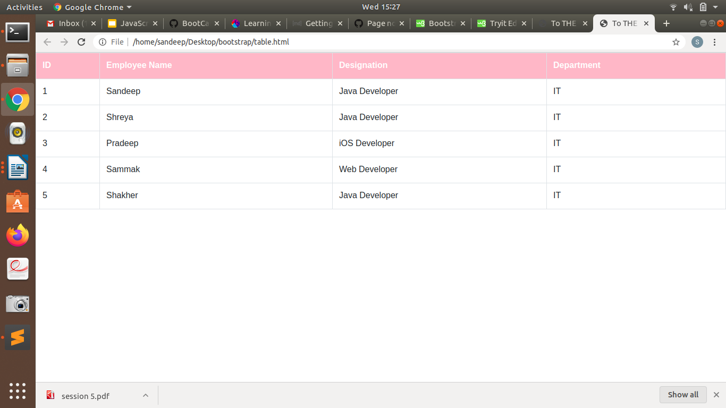
Responsive:
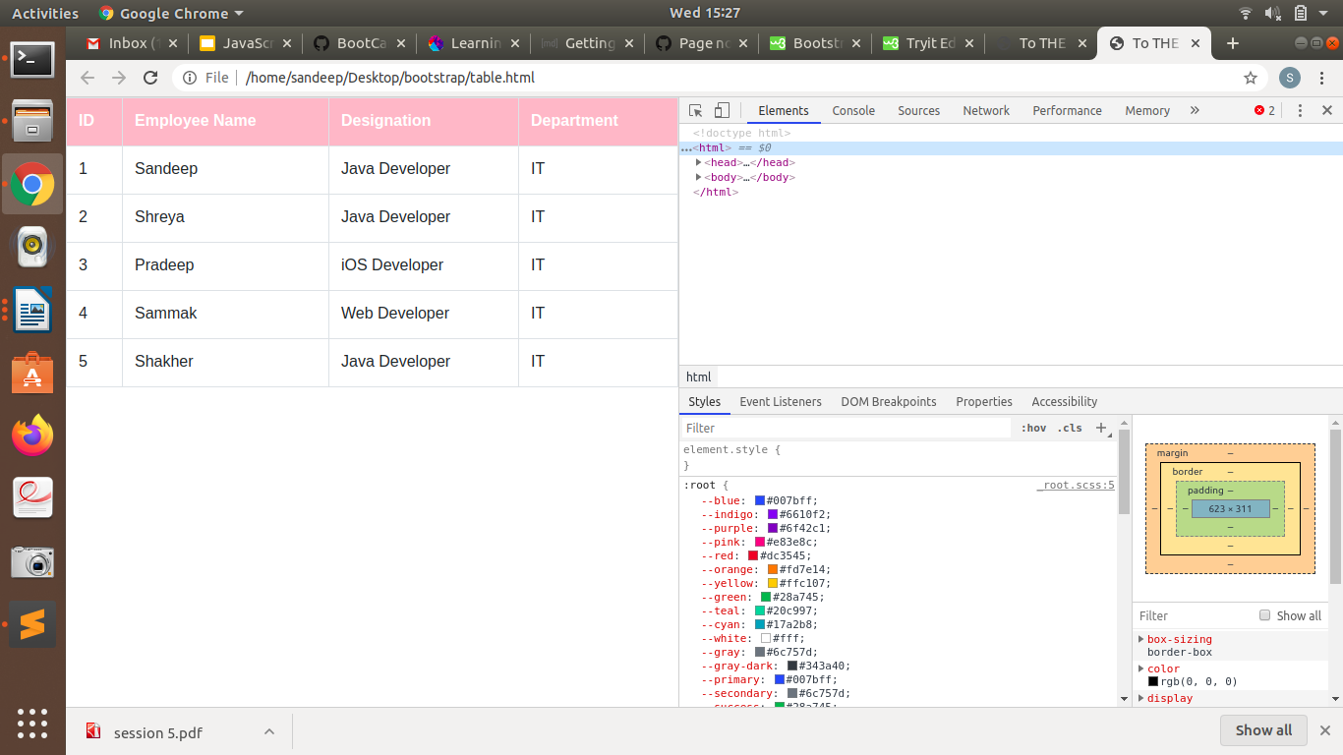

Create HTML for web-page.jpg (check resources, highest weightage for answers)

Script:
<!DOCTYPE html>
<html>
<head>

<meta charset="UTF-8">
<meta name="keywords" content="Java, Javascript">
<meta name="viewport" content="width=device-width, initial-scale=1">
<meta name="description" content=" This my details for google">
<link rel="stylesheet" href="https://maxcdn.bootstrapcdn.com/bootstrap/3.4.1/css/bootstrap.min.css">
<script src="https://ajax.googleapis.com/ajax/libs/jquery/3.4.1/jquery.min.js"></script>
<script src="https://maxcdn.bootstrapcdn.com/bootstrap/3.4.1/js/bootstrap.min.js"></script>
<link rel="stylesheet" href="style.css">
<title>To THE NEW</title>
</head>
<body>
<div id="head" >

<h1>TO THE NEW</h1>

<nav class="navbar navbar-inverse">
<div class="container-fluid">
<div class="navbar-header">
<button type="button" class="navbar-toggle" data-toggle="collapse" data-target="#myNavbar">
<span class="icon-bar"></span>
<span class="icon-bar"></span>
<span class="icon-bar"></span>
</button>
</div>
<div class="collapse navbar-collapse" id="myNavbar">
<ul class="nav navbar-nav">
<li class = "active"><a href="#">Home</a></li>
<li><a href="#">Work</a></li>
<li><a href="#">About</a></li>
<li><a href="#">Contact</a></li>
</ul>

</div>
</div>
</nav>

<div id="body" class="container">

<img id="main_img" src="main.jpg" class="img-rounded img-fluid " width="930" height="360 alt="main" >
<div class="row ">

<div class="col-sm-12" id="para"> <p> THIS IS RANDOM TEXT TO TEST THE FORMATTING AS PER THE GIVEN EXERCISE. I HAPPY, IT IS GOING WELL AS IT SHOULD
I AM JUST WRITING FOR NO REASON AS I HAVE TO FILL ATLEAST TWO LINES. LET'S LOOK AT THE BROWSER!</p></div>

</div>

<div class=" third_block" class="container">
<h4>LATEST FROM GALLARY</h4>
<hr/>

<div id="gallary" >
<div class="row">
<div class=" col-md-3 col-sm-12 "><img src="img1.jpg" alt="main" width="215" height="315"><span >This is image Img1.jpg </span> <br></div>
<div class="col-md-3 col-sm-12 "><img src="img2.jpg" alt="main" width="215" height="315"><span >This is image Img1.jpg </span><br></div>
<div class="col-md-3 col-sm-12 "><img src="img3.jpg" alt="main" width="215" height="315"><span>This is image Img1.jpg </span><br></div>
<div class="col-md-3 col-sm-12"><img src="img4.jpg" alt="main" width="215" height="315"><span>This is image Img1.jpg </span><br></div>
</div>
</div>
</div>

<div id="footer" class="row ">
<span class="left_part">&copy; all right reserved. 2018-20</span>
<span class="right_part" >By sandeep verma</span>
</div>
</div>

</div>

</body>

</html>

Style.css

body{

background-color:#696969;

}
#head{
margin:auto;
background-color:grey;
width:90%;
height:150px;
background-color:#808080;
}

/*BODY*/
#body{
background-color:white;
height: auto;
margin-top:3%;
width:100%;
}

#main_img{
max-width:100%;
margin:auto;
display:block;
margin-top:2%;
margin-bottom:2%;
}

#para{
margin-left:8%;
width:83%;
padding:5px 2px 5px 2px;
background-color:#d3d3d3;
border-radius:5px
}

/*Gallary*/

.third_block{
width:85%;
height:auto;
margin:auto;

}
#gallary .row div span{
background-color:grey;
}
#gallary .row div span,#gallary .row div img{
display:block;
margin:auto;
width:100%;
text-align: center;
}

#footer{
margin-left:-1.5%;
margin-top:80px;
height:60px;
width:103%;
background-color:black;
color:#696969;
}
#footer .right_part{
margin-top:10px;
display:inline-block;
float:right;
margin-right:5px;

}
.left_part{
margin-top:10px;
display:inline-block;
margin-left:5px;

}

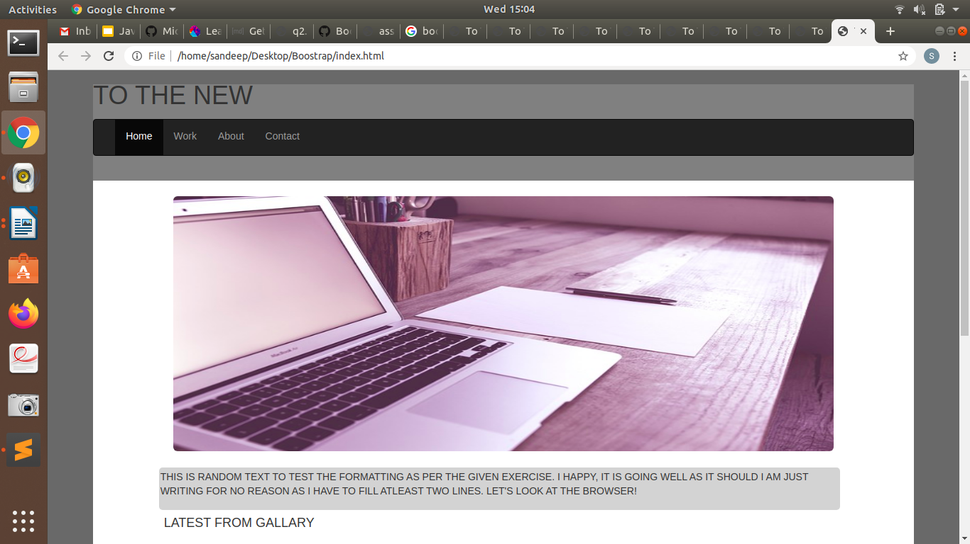
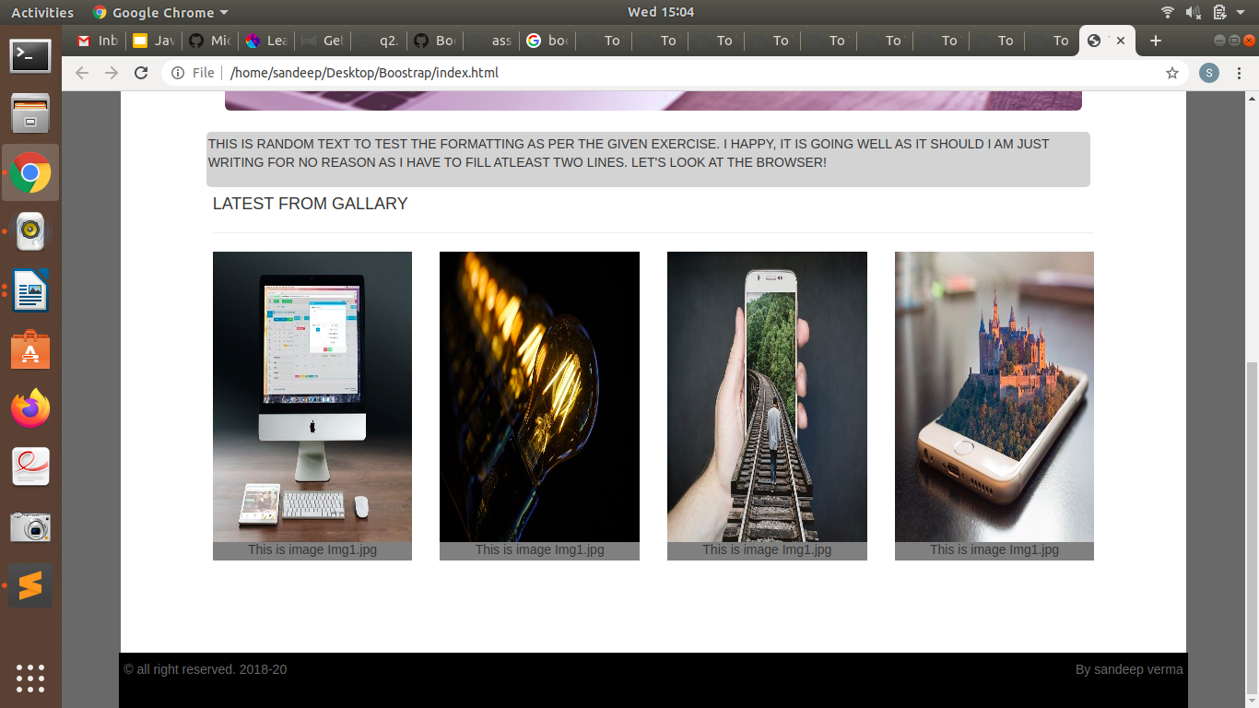

Responsive:

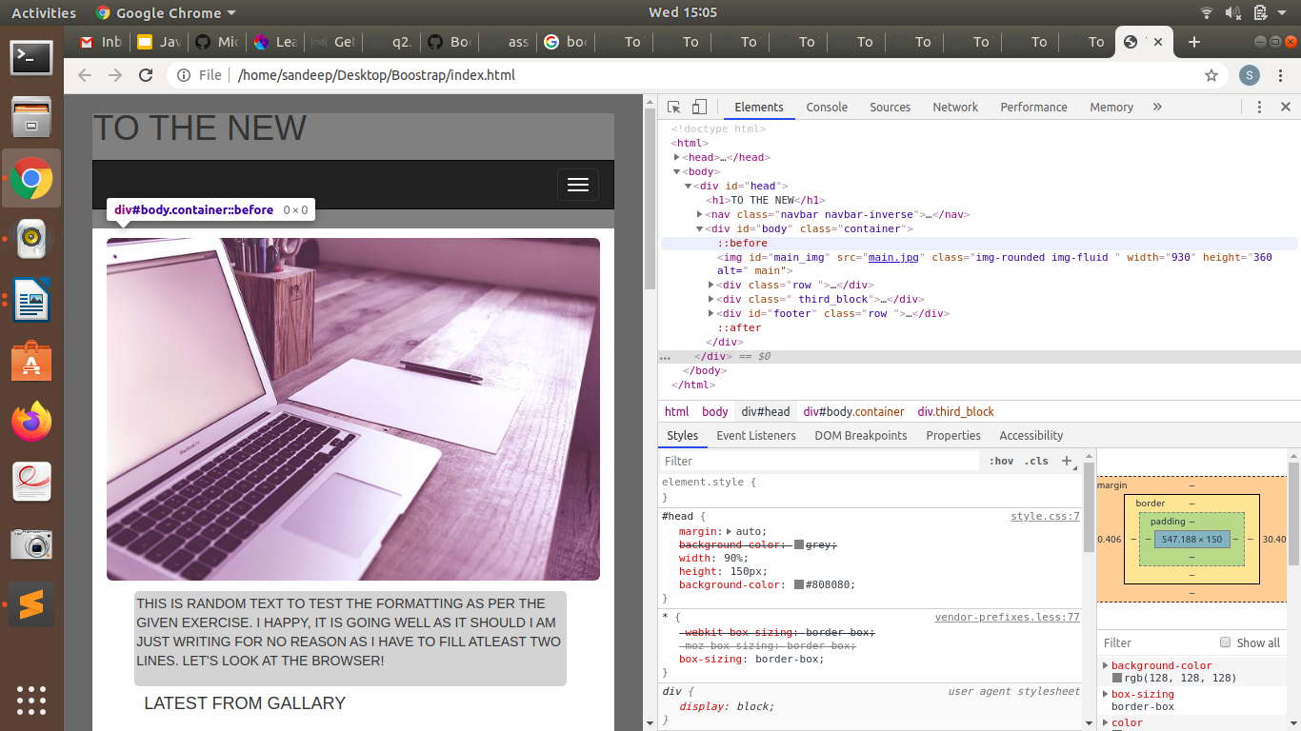
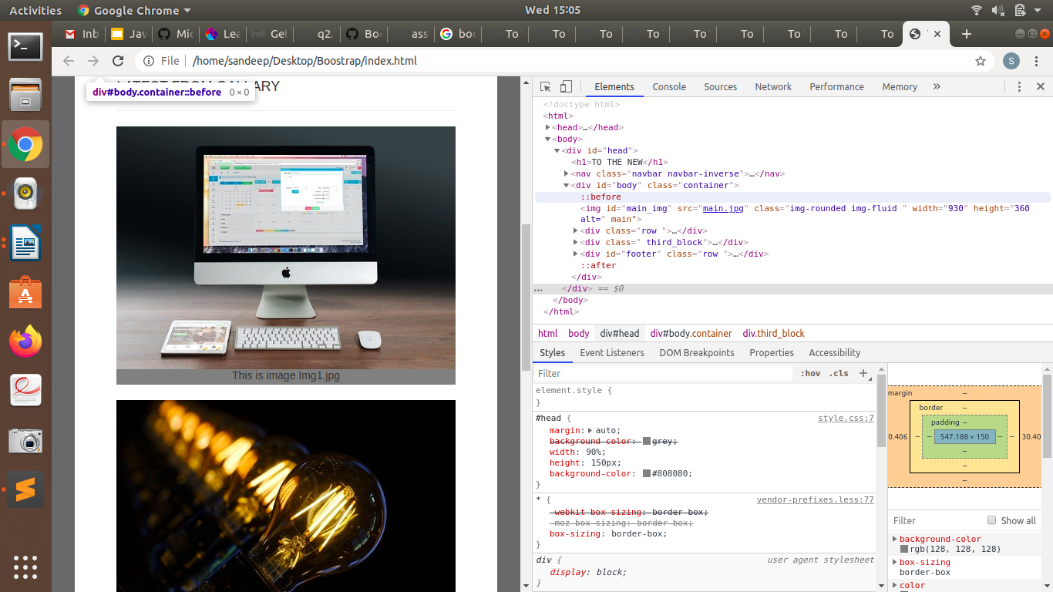

Create HTML for form.png (check resources, highest weightage for answers)

Scripts:
<!doctype html>
<head>
<meta charset="UTF-8">
<link rel="stylesheet" href="https://stackpath.bootstrapcdn.com/bootstrap/4.4.1/css/bootstrap.min.css">
<script src="https://stackpath.bootstrapcdn.com/bootstrap/4.4.1/js/bootstrap.min.js"></script>
<script src="https://stackpath.bootstrapcdn.com/bootstrap/4.4.1/js/bootstrap.bundle.min.js"></script>
<link rel="stylesheet" href="form.css">
<title>TO THE NEW</title>
</head>
<body>
<div id="head" class="container">
<div class="row">
<div class="col-sm-7">
<h4>TO THE NEW</h4>
</div>
<div class="col-sm-5">
<ul class="nav justify-content-end">
<li class="nav-item">
<a class="nav-link active" href="#">HOME</a>
</li>
<li class="nav-item">
<a class="nav-link" href="#">Quick Help</a>
</li>

</ul>
</div>
</div>
</div>
<h3> BUG REPORT</h3>
<form>
<div class="form-group row">
<label for="title">Title*</label>
<div class="col-sm-12">
<input type="text" class="form-control" id="title">
</div>
</div>
<div class="form-group row">
<label for="description">Description*</label>
<div class="col-sm-12">
<textarea class="form-control" id="description" rows="3"></textarea>
</div>
</div>
<div class="form-group row">
<label for="Operating">Operating System </label>
<select class="" id="Operating">
<option class="select"> Windows XP </option>
<option class="select"> Windows 7 </option>

<option class="select"> Windows 10 </option>
<option class="select"> Windows Vista </option>
</select>
</div>
<div class="form-group row">
<label for ="Product"> Product </label>
<select class="" id="Product">
<option value="Windows XP"> Microsoft Access </option>
<option value="Windows 7"> Microsoft Excel </option>
<option value="Windows 10"> Microsoft Outlook </option>
<option value="Windows Vista"> Microsoft One Note</option>
</select>
</div>
<div class="form-group row">
<div class="col-sm-4">
<label for="Version">Version:</label>
<input type="number" class="form-control" id="Version">
</div>
</div>
<div class="form-group">
<label> License</label>
<br/>
<label class="radio-inline">
<input type="radio" name="optradio" checked>Free
</label>
<label class="radio-inline">
<input type="radio" name="optradio">Business
</label>
</div>
<div class="form-group row">
<label> Severity</label>
<select name="Operating System">
<option value="Serious">Serious</option>
<option value="Danger"> Danger</option>
</select>
</div>
<div class="form-group row">
<label> Attachments </label>
<input type="file" name="documents" accept="file/*">
</div>
<div class="form-group">
<div class="divide">
<button type="button" class="btn btn-success float-right">Submit</button>
</div>
</div>
</form>
</body>
</html>

Form.css

#head{
color:#06A061;
border-bottom:0.5px solid #E7E4E4;

}
#head span{
font-size:20px;
color:#06A061;

}
a{color:#06A061;}
h4
{
margin-top: auto;
color:#06A061;
}
h3{
color:white;
width:50%;
padding: 15px 25px 15px 25px;
margin:auto;
margin-top:30px;
background-color: #E7E4E4;
}

.form-group{
border:2px solid #E7E4E4;
color:black;
margin:auto;
width:50%;
}
form label{
font-size:18px;
margin-left:30px;
margin-top:15px;
}
form input,select,textarea{
margin-top:20px;
padding:5px 2px 5px 2px;
width:90%;
margin:auto;
border-radius:5px;
border:1px solid #E7E4E4;
}
.select,select{
background-color:#06A061;
color:white;
border:none;
font-weight:500;
}
.divide{
margin-top:5px;
height:50px;
border-radius:5px;
background-color:#E7E4E4;
}
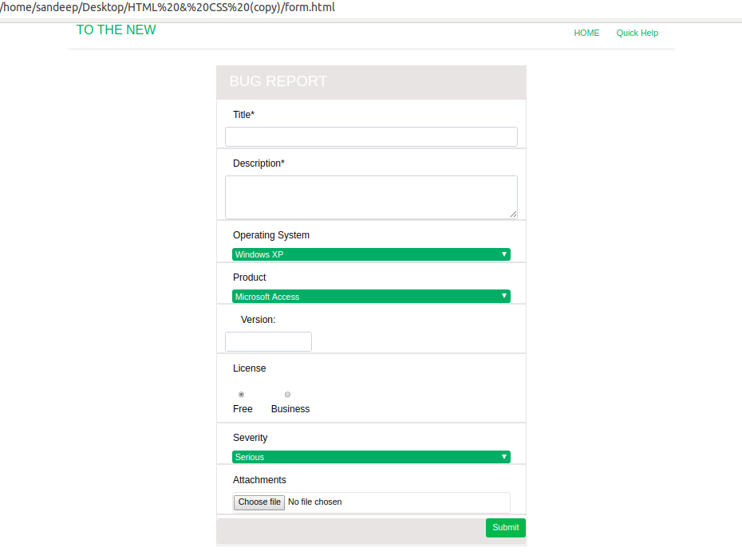

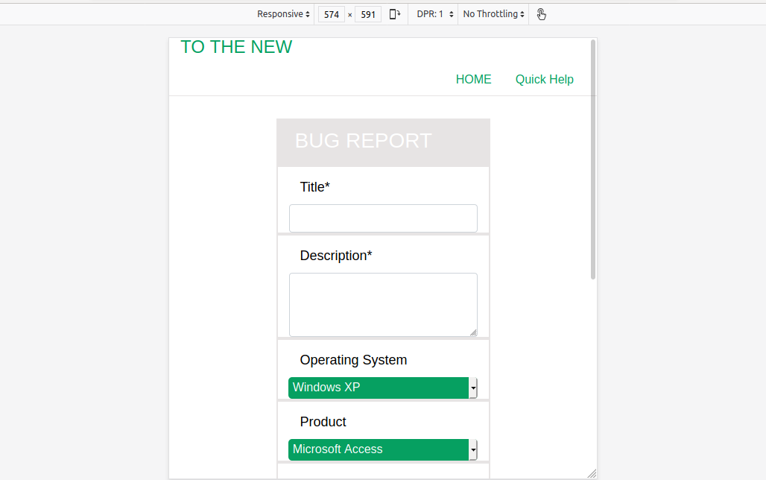
Responsive:

